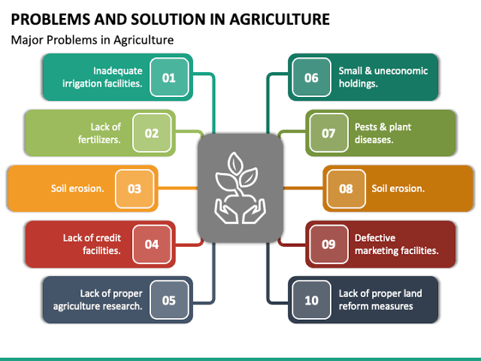

It point out the plant position

It can change the pH value by leaf dimension

Natural resources needed for plants denoted f

The wetness of the soil monitored by moisture device

Sensor will not get varnished in soil

Absorption

pH stage variation

Fertilizers

Irrigation delay

Soil erosion